
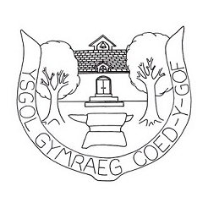
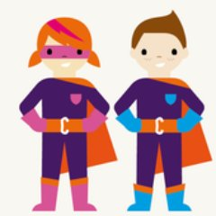
Her 3: Fe fyddwn yn gwrnado ar gerddoriaeth Cymraeg dros yr wythnosau nesaf. Bydd ‘Band yr Wythnos’ yn cael ei enwi yn y gwasanaeth ac ar drydar yr ysgol.

3rd Challenge: We will be listening to Welsh music over the next few weeks. We will announce the name of our ‘Band of the Week’ in school assembly and on the school’s twitter account.

Os ydych chi’n gwneud rhywbeth trwy gyfrwng y Gymraeg tu allan i’r ysgol, dwedwch wrthon ni trwy Drydar @CoedYGof a defnyddio #siarteriaith.

If you take part in anything outside school through the medium of Welsh, let us know through the school’s twitter @CoedYGof and use #siarteriaith.

Dewch a’r llyfr yma nôl i’r ysgol ar ddydd Gwener 16eg o Chwefror. Cewch 1 tocyn iaith am bob rhaglen deledu rydych yn gwylio ac 1 tocyn iaith am bob ap rydych yn chwarae.

Please return this book on Friday the 16th of February. You will receive 1 language token for every programme that you watch and 1 token for every app that you play.
Fy Llyfr
Siarter Iaith
My Welsh Charter Book

Enw/ Name:

Dosbarth/Class:

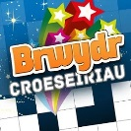

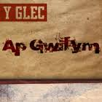
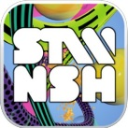
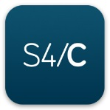
Cymraeg yn y Cyfryngau

Her 1: Sawl rhaglen deledu Cymraeg ar S4C neu CLIC ydych chi’n gwylio bob wythnos? Ysgrifennwch enw’r rhaglen deledu yn y blwch. Defnyddiwch Freeview 4, Sky 104, Virgin 166 neu www.s4c.cymru/clic

1st Challenge: How many Welsh television programmes do you watch on S4C or CLIC? Write the names of the programmes in the boxes. Use Freeview 4, Sky 104, Virgin 166 or www.s4c.cymru/clic

 | Rhaglen  Programme | Rhaglen  Programme | Rhaglen  Programme | Rhaglen  Programme
29/1 – 4/2
5/2 – 11/2
12/2 – 16/2

Welsh in the Media

Her 2: Sawl un o’r apiau yma ydych chi wedi chwarae? Rhowch eich adolygiad wrth ymyl yr ap.

2nd Challenge: How many of these apps have you played? Give your own review next to each one.

Apiau addas i Gyfnod Allweddol 2 / Suitable apps for Key Stage 2

